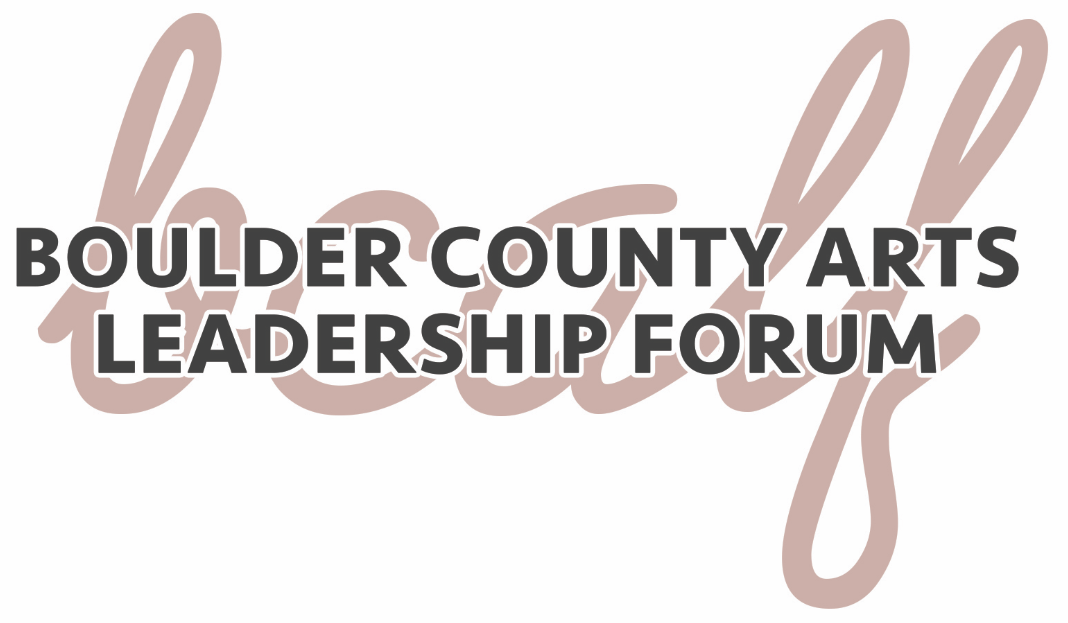
MEMBERSHIP APPLICATION

You are invited to apply to participate in the Boulder County Arts Leadership Forum (BCALF), a program of Boulder County Arts Alliance. BCALF is a group of 8-12 arts professionals working to build a more dynamic, relevant and engaged arts community in Boulder through peer-to-peer learning, support and collaboration.

OUR MISSION
Boulder County Arts Leadership Forum supports and advocates for artists and arts organizations in Boulder County by fostering collaborations, sharing resources, facilitating discussions and creating opportunities to experience art.

Current Forum Members

Charlotte LaSasso, Boulder County Arts Alliance, Director

Sarah Leversee, (BCALF Facilitator) Art as Action, Artistic Director

Pat Connelly, Blue Moon Dance Company, Director

Wes Jessup, Longmont Museum, Director

Jessica Kooiman, Firehouse Art Center, Executive Director/Curator

Betsy Tobin, Now Or Never Theatre, Artistic Director

Juliette Leon Bartsch, Concert Series, Programs, Events & Outreach Specialist, Boulder Public Library

Past BCALF Events include:

“Get to Know your Funders” Panels

“Thirsty Artists’” Monthly Networking Events

“Reinventing Arts Coverage” Media Panels

“Art Abandonment” Projects
“Artist Displacement Panels”
- Forum members take part in monthly meetings emphasizing confidentiality, personal responsibility and the sharing of lessons learned. Meetings include discussions of hot topics in the arts and break-out groups may be formed to discuss leadership concerns or to plan specific actions or events in the community.
- Membership is open to executive directors, key staff, individual artists, and board
members
- The forum is an opportunity to examine how successful arts communities around the country are developed and promoted
- Forum meetings typically take place on the 4th Monday of each month from 3-5:30pm in locations around the county
- Members pay $125 annually in forum dues

Applicant Name _________________________________________________________

Affiliated Organization ____________________________________________________

Address ________________________________________________________________

Phone _______________________ Email _____________________________________

Please state why you would like to be a part of this forum.

______________________________________________________________________

______________________________________________________________________

______________________________________________________________________

Please list any specific topics you would like to see covered during the forum.

______________________________________________________________________

______________________________________________________________________

______________________________________________________________________

Guest experts will be invited to present on select topics. Depending on the priorities set by the new group, Forum members may be asked to give a presentation to the group. Please state an area of expertise in which you would feel comfortable sharing your knowledge with the group.

______________________________________________________________________

______________________________________________________________________

______________________________________________________________________

The forum will take place on the 4th Monday of each month. Once accepted, monthly participation is important for the overall success of the group. Participants that miss more than three meetings/year will be asked to forfeit their membership. Do you feel you could be a regular attendee of forum meetings? ___________________________

Questions? Please contact Charlotte LaSasso at Boulder County Arts Alliance, charlotte@bouldercountyarts.org.

